MONGODB ASSIGNMENT 3

- Total sales per product.
db.sales.aggregate([{$project: {
product: 1,
total_sales: { $multiply: ["$price", "$quantity"]}}},
{$group: {_id: "$product",
total_sales: { $sum: "$total_sales" }}}])
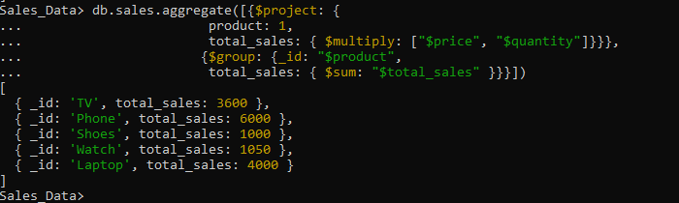
- Total revenue per product.
db.sales.aggregate([{$group:{_id:"$product",
total_revenue:{$sum:{
$multiply:["$price","$quantity"]}}}}])

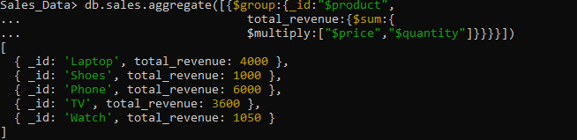

- Total revenue per category.
db.sales.aggregate([{$group:{_id:"$category",
total_revenue:{$sum:{
$multiply:["$price","$quantity"]}}}}])
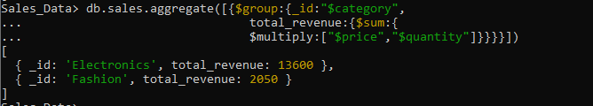
- Count of products per category.
db.sales.aggregate([{$group:{_id:"$category",
prod_category:{$sum:"$quantity"}}}])
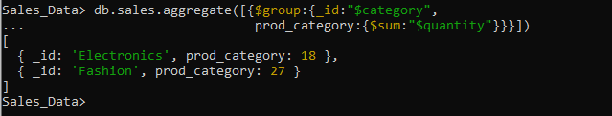

- Store-wise total sales.

db.sales.aggregate([{$group:{_id:"$store",
total_revenue:{$sum:{
$multiply:["$price","$quantity"]}}}}])

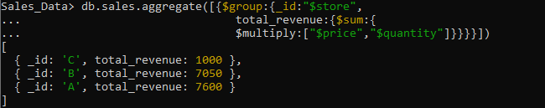
- Average price of products per category.
db.sales.aggregate([{$group:{_id:"$category",
avg_price:{$avg:"$price"}}}])
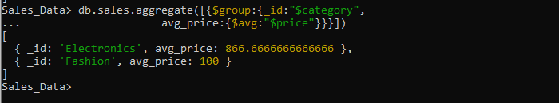

- Top-selling product.
db.sales.aggregate([{$group:{_id:"$product",
top_product:{$sum:"$quantity"}}},
{$sort:{top_product:-1}},{$limit:1}])
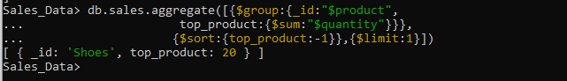

- Total sales for Electronics category.
db.sales.aggregate([{$match:{category:"Electronics"}},
{$group:{_id:null,revenue:{$sum:{$multiply:["$price","$quantity"]}}, sales:{$sum:"$quantity"}}}])
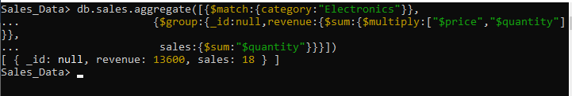
- Sales trend over time (day-wise total sales).
db.sales.aggregate([{$group:{_id:{$dateToString:{format:"%Y-%m-%d",date:"$date"}},
sales:{$sum:{$multiply:["$price","$quantity"]}}}},
{$sort:{_id:1}}])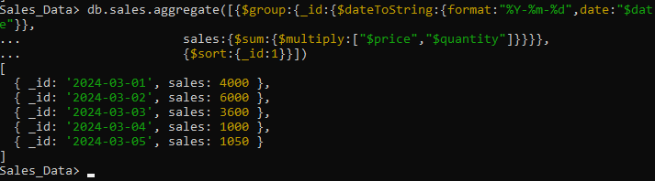

- Highest revenue-generating product.
db.sales.aggregate([{$group:{_id:"$product",
sales:{$sum:{$multiply:["$price","$quantity"]}}}},
{$sort:{sales:-1}},{$limit:1}])

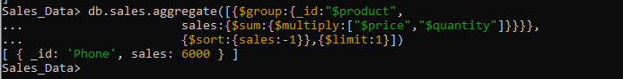
- Average revenue per sale.
db.sales.aggregate([{$group:{_id:null,
avgrevenue:{$avg:{$multiply:["$price","$quantity"]}}}}])
- Sales performance per store.
db.sales.aggregate([{$group:{_id:"$store",
revenue:{$sum:{$multiply:["$price","$quantity"]}},
sales:{$sum:"$quantity"}}}])
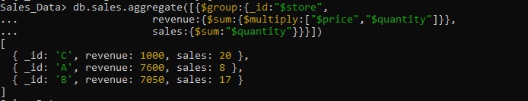
- Products sold more than 5 times.
db.sales.aggregate([{$group:{_id:"$product",qty_sold:{$sum:"$quantity"}}},
{$match:{qty_sold:{$gt:5}}}])
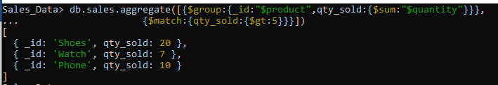
- Least sold product.
db.sales.aggregate([{$group:{_id:"$product",qty_sold:{$sum:"$quantity"}}},
{$sort:{qty_sold:1}},{$limit:1}])

- Monthly sales summary.
db.sales.aggregate([{$group:{_id:{$dateToString:{format:"%Y-%m",date:"$date"}},
revenue:{$sum:{$multiply:["$price","$quantity"]}},
sales:{$sum:"$quantity"}}}])
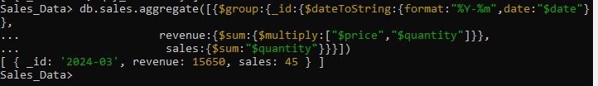
- Number of unique products sold.
db.sales.distinct("product").length
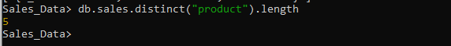
- Maximum and minimum priced product.
db.sales.aggregate([{$sort:{"price":-1}},
{$group:{_id:null,
max_price_prod:{$first:"$product"},max_price:{$first:"$price"},
min_price_prod:{$last:"$product"},min_price:{$last:"$price"}}}])
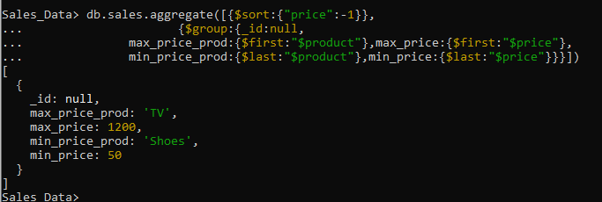
- Total revenue per product in descending order.
db.sales.aggregate([{$group:{_id:"$product",
total_revenue:{$sum:{$multiply:["$price","$quantity"]}}}},
{$sort:{total_revenue:-1}}])
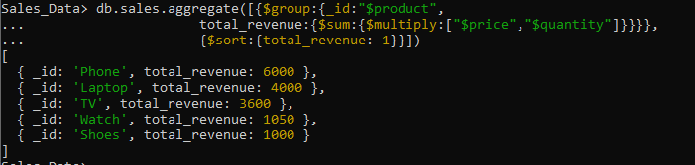
- Revenue generated per store per category.
db.sales.aggregate([{$group:{_id:{store:"$store",category:"$category"},
total_revenue:{$sum:{$multiply:["$price","$quantity"]}}}}])
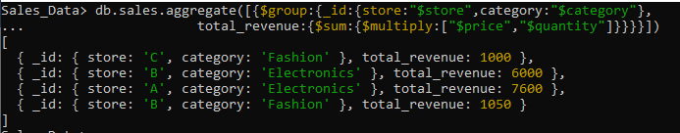
20. Products contributing more than 50% revenue.
db.sales.aggregate([{$group:{_id:null,
total_revenue:{$sum:{$multiply:["$price","$quantity"]}}}},
{$group:{_id:"$product",
prod_revenue:{$sum:{$multiply:["$price","$quantity"]}}}},
{$match:{$expr:{$gt:["$prod_revenue",{$multiply:["$total_revenue",0.5]}]}}}]) 